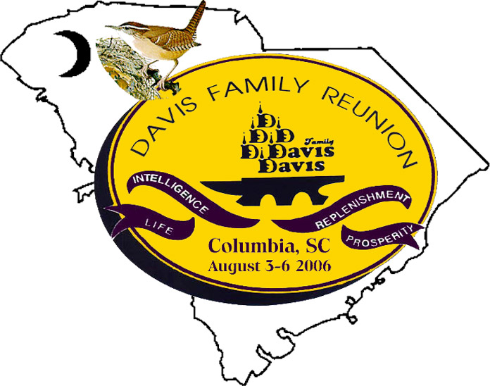
March 15, 2006

PRESIDENT’S CORNER
Greeting!

I pray this newsletter find you will and richly blessed in the Lord. The 2006 Family Reunion is rapidly approaching and there’s much to do. For a successful reunion, participation and commitment is very important, therefore I am soliciting as much participation as possible from you. I am enclosing a response sheet for you to complete and return as soon as possible. Please forward the newsletter and response sheet to other family members that we have not contacted or those family members that are not on the mailing list.

Our family reunion is a ritual that continues despite constant changes. It is a chance to reminiscence about the past and be introduced to the future. Please come and join us in Columbia, SC for the 2006 Family Reunion from August 3, 2006 to August 6, 2006.

If you have not paid for the Family Reunion, your cost is $75.00 per adult (age 16 - 64). Please check the payment schedule, which is attached. We need your help and your financial support in order to have a successful reunion. Please mark all deadline dates on your calendars and promptly return your response sheet along with your payment BY THE DEADLINE DATE. It is imperative that we get an accurate count so that proper planning can be made for seating, catering, T-shirts, etc.

Again, this reunion will take the efforts of all family members, so please plan to attend. If you have any question or need additional information, please do not hesitate to contact one of the committee members.

Henry E. Goodson, President

RESERVATION

CAROLINIAN HOTEL
- TWO NOTCH ROAD
COLUMBIA, SC 29223
PHONE: (803) 736-3000
FAX: (803) 786-2467
RESERVATION: (877) 308-4986

The Family Reunion will be held from August 3, 2006 to August 6, 2006.

A block of rooms are reserved at the Carolinian Hotel. Each person is responsible for contacting the hotel and making his or her individual reservation. The cost per night is $69.00 plus 11% sales tax. All reservations must be made by June 30, 2006.

COST FOR THE FAMILY REUNION

AGE COST
0 – 6 years free
7 – 15 $45.00
16 – 64 $75.00
65 – OLDER $65.00

This cost is good through May 31, 2006. Payment must be paid in full by May 31, 2006. After May 31, 2006 the payment will increased. (SEE THE ATTACHED PAYMENT SCHEDULED).

REMEMBER: NO CHEKS WILL BE ACCEPTED AFTER JUNE 30, 2006.

MAKE CHECKS PAYABLE TO:

DAVIS FAMILY REUNION

MAIL PAYMENTS TO:
Davis Family Reunion
Attn.: Willene Myers Ross
1864 Jaywood Circle
Charleston, SC 29407

2006 DAVIS FAMILY REUNION TREASURER REPORT

From 2004 – 2005 Reunion $ 0.00
Deposit Collected August 6, 2005 510.00
Dues Collected Aug – Sept. (mail in) 65.00
Subtotal: September 1, 2005 575.00
Expenses & Payment (Postage Stamps) -50.00
Ending Balance: September 1, 2005 $ 525.00

October 2005 – March 2006
Monies Received (Credits $ Payments) $1225.00
Expenses & Payment (Debits & Payments) -300.00
Ending Balance March 20, 2006 $1450.00
A list of family member who have paid for the family reunion
is attached.

PLEASE HELP ME LOCATED THESE FAMILY MEMBERS. THERE NEWSLETTERS WAS RETURN:

Mrs. Ruby Williams
Mr. Bernard Richardson
Mrs. Kemba S. Lydia
Ms. LaTanya Thompson
Mr. Nathaniel Davis
Ms. Alberta Boyd
Ms. Brenda Young-Moore
Ms. Gardenia Bert Javis

Please complete the response form and the survey and return to Henry Earl Goodson as soon as possible.

TENTATIVE AGENDA

Thursday, August 3, 2006

3:00 PM – 7:00 PM Registration (Hotel)
7:00 PM – 10:00 PM Fish Fry and Social Hours
10:00 PM – 11:00 PM Clean up
Fair Lawn Community Center
Wilson Blvd. (North Main Street)
Blythewood, SC 29016

Friday, August 4, 2006

6:30 AM – 9:00am (for young adults) Fishing Trip

Earls’ Fishing Pond

7:30 AM – 9:00am Hospitality Suite Hotel Craft Workshop

11:00 AM – 2:00 PM EdVenture at SC State
Museum or Frankie Fun Park
7:00 PM – until Carolinian Hotel Banquet
11:30pm - 2:30pm Clubbing / Bowling

Saturday, August 5, 2006
9:00 AM – 11:00am Tour/Shopping
2:00 PM – until Fair Lawn Community Center Family & Friends Outing
Family Meeting

Sunday, August 6, 2006
10:30 AM Church Service
Cedar Creek AME Church

**This is just a tentative agenda. Activities may change

.

2006 DAVIS FAMILY REUNION RESPONSE FORM

PLEASE RETURN THIS FORM TO:
Henry E. Goodson
127 Murdock Street
Columbia, SC 29203

If you have already paid for the reunion, please complete this form and return it the Earl.

MAILED ALL REUNION PAYMENT TO:
Davis Family Reunion
Willene Ross
1864 Jaywood Circle
Charleston, SC 29407

The Cost of the Reunion

